**MAULANA AZAD NATIONAL INSTITUTE OF TECHNOLOGY BHOPAL**

**DEPARTMENT OF CSE**

Name: Yashwant Patidar

Scholar Number: 191112243

Section: CSE 2

3rd SEM BTech

Subject: Principles of Programming Languages Lab - CSE 219

**Lab Assignment**

**Question 1:** WAP to delete all vowels from the string using call by value.

**Program code:**

#include <iostream>

#include <bits/stdc++.h>

using namespace std;

string replaceVowels(string s){

    regex reg("[aeiouAEIOU]");

    return regex_replace(s,reg,"");

}

int main() {

    string s1,s2;

    cout<<"Enter the String: ";

getline(cin,s1);

    s2 = replaceVowels(s1);

cout<<"\nOriginal String: "<<s1<<endl;

cout<<"\nNew string with removed vowels: "<<s2;

}

**Output:**

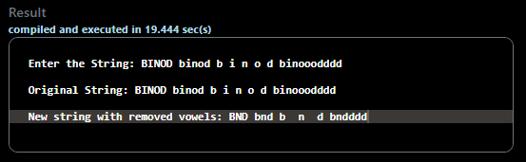

**Question 2:** WAP to increment the alphabets of a string by one alphabet using call by reference.

**Program Code:**

#include <iostream>

#include <bits/stdc++.h>

using namespace std;

void nextAlpha(char *ptr){

    while(*ptr!='\0'){

        if(isalpha(*ptr))

            if(*ptr == 'z')     *ptr = 'a';

            else if(*ptr =='Z') *ptr = 'A';

            else                *ptr +=1;

        ptr++;

    }

}

int main() {

    string s;

    cout<<"Enter the String: ";

    getline(cin,s);

    nextAlpha(&s[0]);

    cout<<"\nThe string with incremented alphabets: "<<s;

}

**Output:**

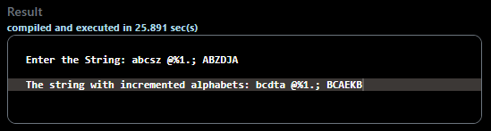

**Question 3:** WAP to check string 1 is a substring of string 2 or not.

**Problem Code:**

#include <bits/stdc++.h>

using namespace std;

int isSubstr(string s, string sub)

{

    Inti,j,l1 = s.length();

    int l2 = sub.length();

    for (i = 0; i <= l1 - l2; i++) {

        for (j = 0; j < l2; j++)

            if (s[i + j] != sub[j])

                break;

        if (j == l2)

            return i;

    }

    return -1;

}

int main()

{

    string s,sub;

    cout<<"Enter string: ";

    getline(cin,s);

    cout<<"Enter the string to search: ";

    getline(cin,sub);

    int index = isSubstr(s, sub);

    if (index == -1) cout << "\nThere is no such substring in the string";

    else cout << "\nThe substring is at index: " << index;

    return 0;

}

**Output:**

